**Analysis and design of the client registration page.**

1. **User story description.**

|  |  |
| --- | --- |
| Use case name | Client Registration |
| Use case scenario | Client registration scenario. |
| Level | Black level |
| Use case triggering event | User/New client go to PrimeL website to fill a form for registration in order to have an account and login |
| Scenario description | New client to enter registration details; Email address which is the registration ID, Company Name, Contact Name, Contact Telephone, Contact Mobile, Contact Role, Company Total Employees and Company IT Employees |
| Primary actor | New client |
| Related use cases | Include: Candidate Registration, User Login. |
| Precondition | User needs to have an email address, all input fields are entered correctly. |
| Post condition | Selected details should be associated with the user  The web application will successfully register the client  The web application will generate login details for client after registration  If unsuccessful the registration process will rollback and client advised accordingly |
|  | Actor The web application |
| Flow of activities | 1.The user to go the PrimeL website to  login |
|  | 2. If user is new the he or she registers 2.1 Create account for new user |
|  | 3. Client to enter Email address which 3.1 Validate details  is the registration ID, Company name,  Contact Name, Contact Telephone,  Contact Mobile, Contact Role,  Company  Total Employees and Company IT  Employees    3.2 Register user |
| Exception conditions | 3.1If user enters wrong details, the web application will generate a temporary password and send to email which the user can change afterwards.  3.2 If details are not correct such as emails address, name and mobile number, the web application does not process the registration and facilitates for user to enter correct details to proceed to next step or the user can cancel the registration process |

1. **Use case.**

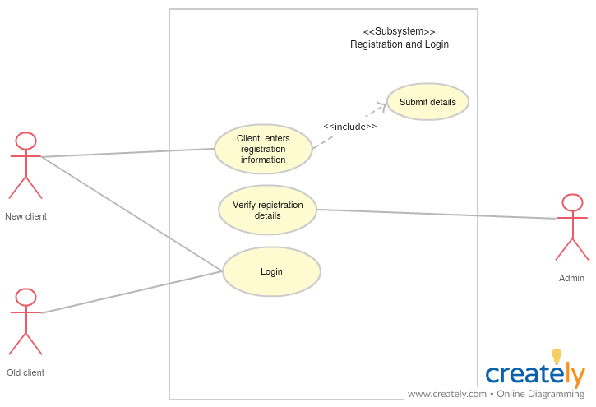

1. **Data flow diagram.**

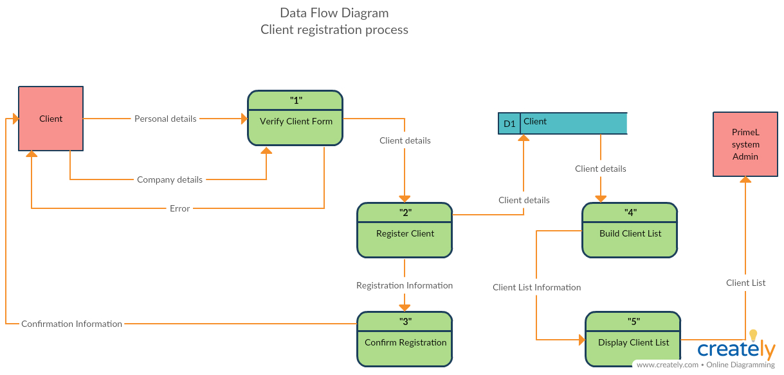

1. **Sequence diagram.**

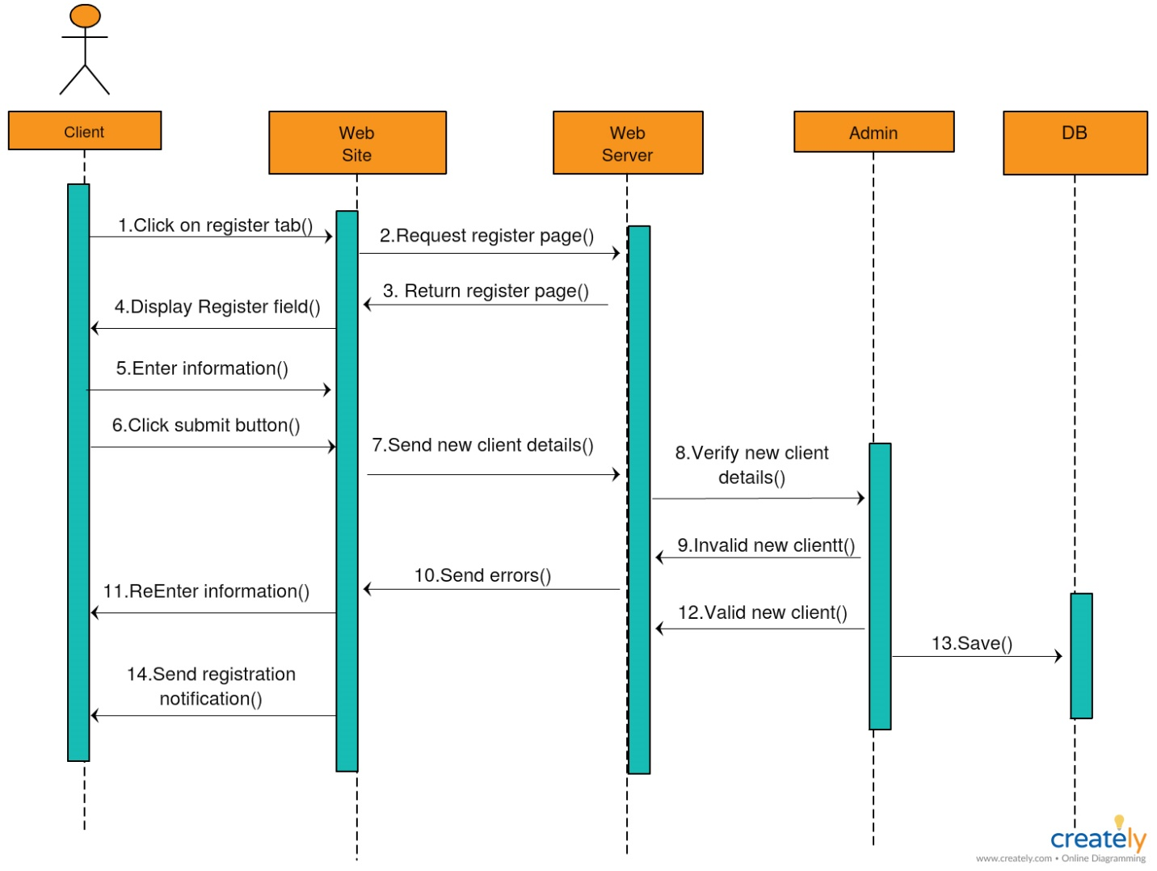

1. **ER Diagram**

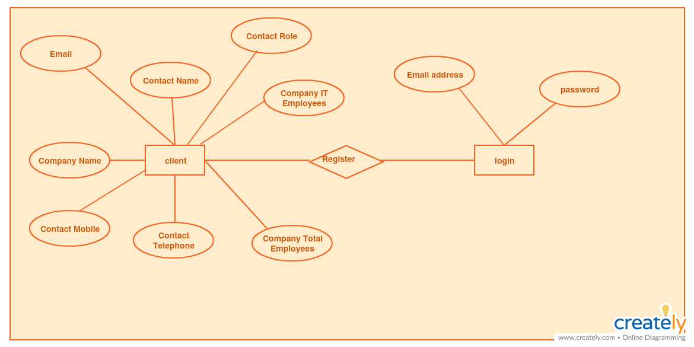

1. **Wireframe of the client registration form.**

